Asia-China-Coin-Knife-NEW

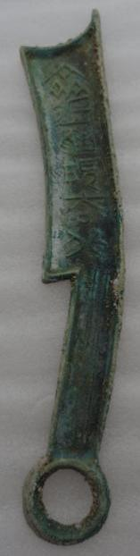 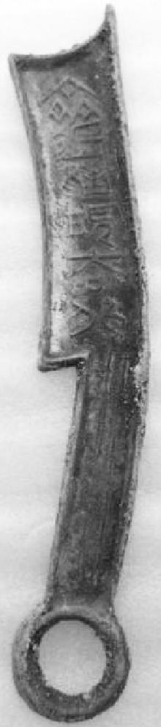

H 4.4 R 5

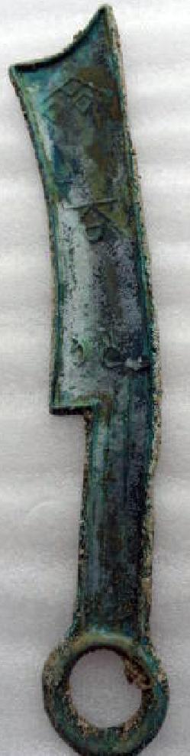 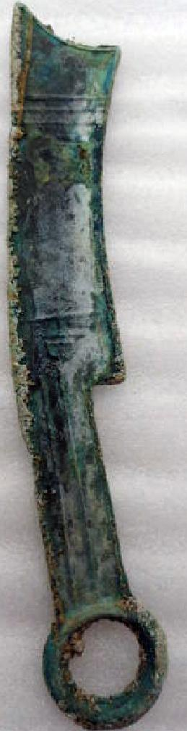

H 4.6 R 7

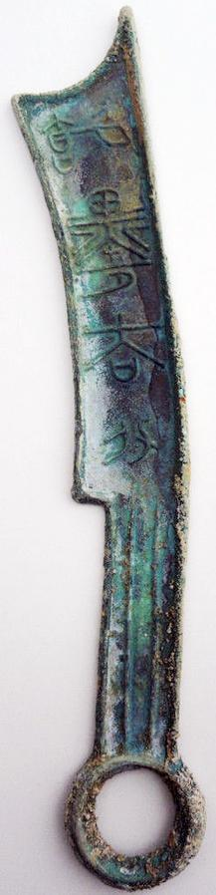 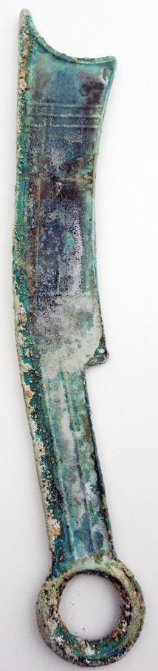

H 4.2 R3